**Add Page**

A report is a list of records that meet the criteria you define. It's displayed in rows and columns, and can be filtered, grouped, or displayed in a graphical chart. Every report is stored in a folder.

Folders can be public, hidden, or shared, and can be set to read-only or read/write.

There are 4 types of report formats in Salesforce:

#### Tabular Reports:

This is the most basic report format. It just displays the row of records in a table with a grand total. While easy to set up they can’t be used to create groups of data or charts and also cannot be used in Dashboards. They are mainly used to generate a simple list or a list with a grand total.

#### Summary Reports:

It is the most commonly used type of report. It allows grouping of rows of data, view sub total,and create charts.

#### Matrix Report:

It is the most complex report format. Matrix report summarizes information in a grid format. It allows records to be grouped by both columns and rows. It can also be used to generate dashboards. Charts can be added to this type of report.

#### Joined Reports:

These types of reports let us create different views of data from multiple report types. The data is joined reports are organized in

blocks. Each block acts as a sub report with its own fields, columns, sorting, and filtering. They are used to group and show data from multiple report types in different views.

#### Report types*:*

Report type determines which set of records will be available in a report. Every report is based on a particular report type. The report type is selected first when we create a report. Every report type has a primary object and one or more related objects. All these objects must be linked together either directly or indirectly.

* A report type cannot include more than 4 objects.
* Once a report is created its report type cannot be changed.

There are 2 types of report types:

#### Standard Report Types:

Standard Report Types are automatically included with standard objects and also with custom objects where “Allow Reports” is checked.

Standard report types cannot be customized and automatically include standard and custom fields for each object within the report type. Standard report types get created when an object is created, also when a relationship is created.

**Note:** *Standard report types always have inner joins.*

#### Custom Report Types:

Custom report types are reporting templates created to streamline the reporting

process. Custom Reports are created by an administrator or User with “Manage Custom

Report Types” permission. Custom report types are created when standard report types cannot specify which records will be available on reports.

In custom report types we can specify objects which will be available in a particular report.

The primary object must have a relationship with other objects present in a report type either directly or indirectly.

There are 3 types of access levels of folders:

#### Viewer:

With this access level, users can see the data in a report but cannot make any changes except cloning it into a new report.

#### Editor:

With this access level, users can view and modify the reports it contains and can also move themto/from any other folders they have access level as Editor or Manager.

#### Manager:

With this access level, users can do everything Viewers & Editors can do, plus they can alsocontrol other user’s access levels to this folder. Also, users with Manager Access levels can delete the report.

**Create Report**

1. Click App Launcher
2. Select **Candidate Internal Result Card** App
3. Click reports tab
4. Click New Report.
5. Click the report type as Semesters with Course Click **Start report.**
6. Customize your report, in group rows select - **Course Name**, in group column Select **Duration** (In this way we are making a Matrix Report).
7. Click refresh
8. Click save and run
9. Give report name – **Candidate Internal Result Report**

10. Click Save

**NOTE:** In this report you can see your all record of the object you selected for reporting (What

you Selects in “Select a report type option”).

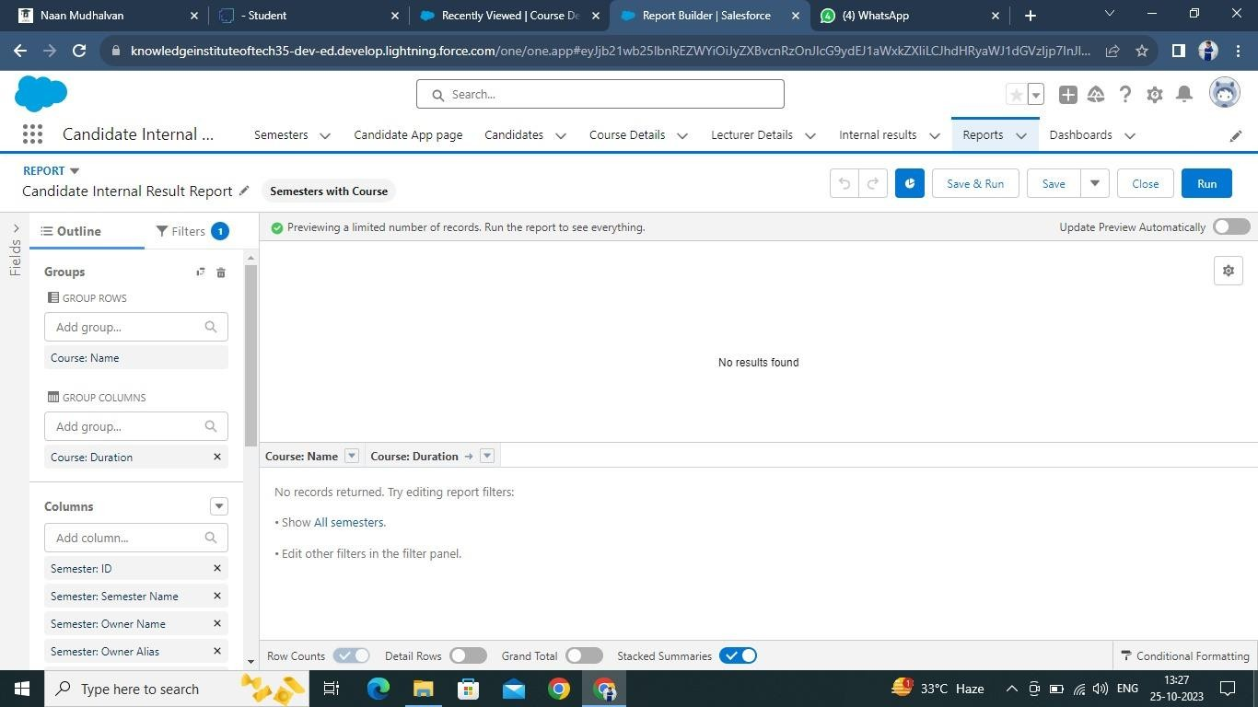

### View Report

1. Click on App Launcher on left side of screen.
2. Search **Candidate Internal Result Card** App & click on it.
3. Click on Reports Tab.
4. Click on **Candidate Internal Result Report** and see records.

